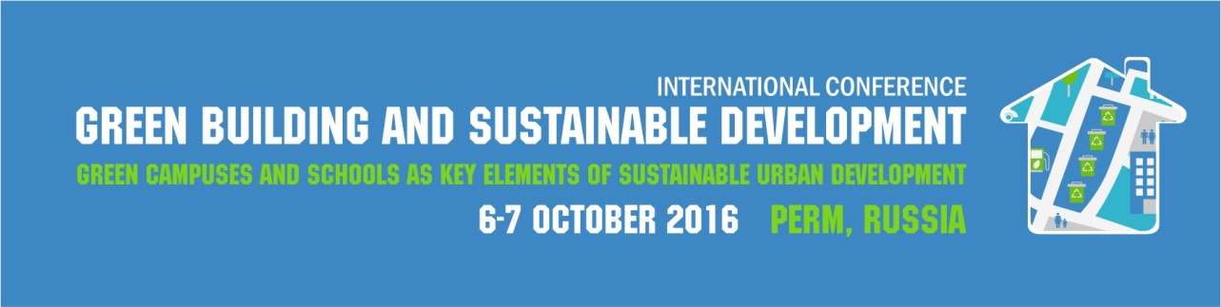

REGISTRATION FORM FOR PARTICIPANTS

Surname
Name
Middle Name
Title and position
Institution (full name and abbreviation)
Postal address of the institution
Phone number
Fax number
E-mail address
Form of participation*
Session of the conference **
Topic

* oral presentation / poster presentation / attendee
** please copy-paste one of the following:
1. Sustainable development of urban territories. Green campuses and schools.
2. Green construction technologies.
3. Green building and effective waste management.

